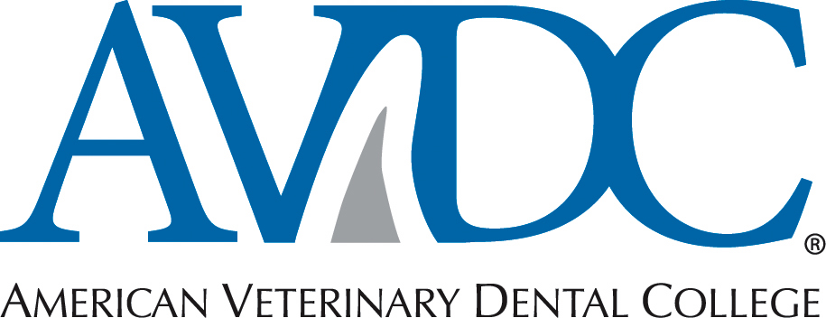

Use this form for re-certification of your RESIDENCY SITE.
Site approval is subject to re-evaluation by AVDC every five years.

A Residency Program approved by the American Veterinary Dental College is a full-time, structured training program allowing an individual to gain in-depth knowledge of all major aspects of veterinary dentistry and related basic sciences, under direct supervision and guidance of an active Diplomate of the American Veterinary Dental College.

Note that separate approval of the individual resident’s program is required (see Residency Program Application, available at http://www.avdc.org/registering-program.htm).

Objectives of a Residency Program:
- To promote aptitude and clinical proficiency in the diagnosis, treatment and aftercare of animals with oral disease(s).
- To provide learning opportunities to review the basic sciences pertaining to veterinary dentistry.
- To provide exposure to a wide range of dental products and instruments.
- To provide the opportunity to pursue career goals in teaching, research, clinical service and/or specialty practice.

Definitions relating to residency training and supervision:

Residency Director: The AVDC Diplomate responsible for supervising AVDC residency training program(s) at an approved site, signing all documentation verifying completion of the program, the continuity of the program, and all correspondence with the AVDC.

Supervising Diplomate: An active AVDC Diplomate responsible for direct supervision of a resident while the resident is in clinical training. In programs with a single AVDC Diplomate present, the Supervising Diplomate is the Residency Director.

Direct supervision: The Supervising Diplomate or Residency Director and the resident are participating in a clinical practice approved for residency training and in which both the Diplomate and the resident are on duty interactively and concurrently managing cases.

An AVDC Diplomate may supervise a total of three residents (or trainees registered in another type of AVDC training program) whose credentials have not yet been accepted. An approved residency program site may have more than three residents, provided there are not more than three applicants per Supervising Diplomate.

Responsibilities of the Program Director:
1. Five-year re-evaluation of site approval.
2. Inform the AVDC of substantial changes in the residency site or program.
3. Support the applicant in preparing the individual residency program application.
4. Monitor the case-load and progress of the resident.
5. Certify the satisfactory completion of the residency program.
6. Reading the AVDC mentor manual annually, case log document, and latest “Changes” document for the year.
7. Provide the infrastructure for the resident to prepare materials required by the AVDC.

Responsibilities of the Program Director or Supervising Diplomate:
1. Provide direct supervision of the clinical activities of the resident.
2. Verify the case-log and other training program documentation required by the AVDC.
3. Review the credentials application materials prepared by the resident prior to submission to AVDC.

Re-evaluation of Residency Sites:

Library:

- Have you added newly published veterinary dentistry and oral surgery textbooks to your library?
Please list which new publications you have added to your library since the last:
- Have you added any new human dentistry text books or periodical publications to your library?
Please list which new publications you have added to your library:

Laboratory Services:

- Has any equipment been deleted or added to the general list provided during the initial residency site application that would allow you to meet your obligations to operate a residency site or improve your operation as a residency site? Please list:

Radiographic and Imaging Equipment:

- Please list your intraoral radiographic imaging equipment:
- Please list your standard radiographic unit for obtaining thoracic radiographs and skull radiographs on patients:
- Please list your advanced imaging equipment (CT and MRI) or where you have access for your patients to obtain advanced imaging nearby:

Dental Laboratory:

- Has anything changed allowing residents access to your dental laboratory?

Dental Operatory:

- Does your dental operatory(s) still allow operating at a specialist level compatible with current concepts of veterinary dentistry and adequate size for appropriate numbers of support staff and equipment and meet applicable regulations.

Surgical Suite:

- Do you have access to a surgical operatory for clean-contaminated head and neck procedures?

Sterilization Facilities:

- Have you added or replaced any sterilization equipment in your practice? If so, please list:

Medical-Dental Records:

- Has there been a significant change in your medical and dental record system since the initial application and approval? If so, please explain:

Training in Related Specialties:

- Residency director should be familiar with current specialty hours requirements. Do you have an updated plan in place so that your residents have appropriate time, access, and availability to complete specialty training hours in Anesthesia, Surgery, and Radiology? Please provide an updated plan:

Additional Re-certification Questions:

- Has anything changed since the last evaluation of your residency site that would not allow you to meet the obligations listed above?

- Has your practice moved locations? If so, Please provide new address:

- Do you practice at any other locations other than the currently approved residency site?

- If so, does it meet all the requirements necessary for the original site approval and recertification approval? Please explain:

- Has your practice purchased any new, major dental equipment that enhances and improves the residency site? Please list:

- Please include a copy of your original equipment list, updated to reflect the current instruments and equipment at the Residency Site.

- Are there any other diplomates of the AVDC at your practice? Please list:

- How many residents (full and part-time) have you had since the last residency site evaluation? Please list names whether they have received diplomate status or not:

- How many of your residents have passed boards?

- How many of your residents have credentialed and are planning on taking boards?

- How many residents are currently in your residency program?

Thank you for your submission of the 5-year AVDC Re-certification Residency Site Application.

The American Veterinary Dental College reserves the right to evaluate and verify answers to these questions with an onsite visit of TSC and/or BOD members or virtual online visit with TSC and/or BOD members.

Physical onsite visits will be provided a minimum of fourteen (14) day written email notice to the residency director. Virtual online visits via Facetime, GoToMeeting, or Skype will be provided a written email three (3) day notice to the residency directory.

Resident | 1st year | 2nd year | 3rd year | Credentialed | Passed Phase 1 | Passed boards | Has not passed
Person A
Person B
Person C
Person D

